README for running the Matlab implementation of the tracking algorithm described in the paper “Robust single particle tracking in live cell time-lapse sequences” by Jaqaman et al.:

Installation:

The software has been tested on Matlab R2006a. It can run under Windows 32-bit, Linux 32-bit and Linux 64-bit. It cannot run under Mac or Windows 64-bit.

The software requires the following Matlab toolboxes:
- Control System
- Image Processing
- Neural Networks
- Optimization
- Signal Processing
- Simulink
- Statistics
- Symbolic Math
- System Identification

The download contains three code directories: detection, tracking and visualization and one example directory: example. The detection, tracking and visualization codes can be run either from within these directories or by adding the directories to the Matlab path.

As in the paper, in our terminology tracking is separate from detection. Detection locates the particles in each frame of a movie, while tracking uses the detection results and links the detected particles into trajectories.

Detection:

In the detection directory, we supply a code (scriptDetectGeneral) for the detection of sub-diffraction objects, as presented in Supplementary Note 2. Importantly, the detection step is application specific. Thus, the detection and tracking codes in the software package are not linked and alternative detection codes can be used.

The detection results must be presented in the following format (which is the automatic output of scriptDetectGeneral):

The detection results should be in a Matlab structure called movieInfo (Fig. 1). If the movie consists of N frames, movieInfo will be an N×1 structure array (i.e. one entry per frame). The structure movieInfo must contain at least 3 fields: xCoord (x-coordinates of particles), yCoord (y-coordinates of particles) and amp (signals of particles). If the application is 3D, then there must be a 4th field, zCoord (z-coordinates of particles). If there are P particles in frame i, each of xCoord, yCoord, zCoord (if applicable) and amp will be a P×2 array (i.e. one row per particle). The first column contains the value (e.g. x-coordinates of particles). The second column defines the values’ standard deviations (if unknown, put 0).

To run the detection code:

(1) Open the file scriptDetectGeneral.m from the Matlab command line (Fig. 1).
(2) Define the required parameters (explained in scriptDetectGeneral):
(i) Movie parameters: Note that movies should be stored as a series of tiff images, following the convention filenameBase_index.tif. The index should always have the same number of digits for a series of tiff images (e.g. images 1, 10 and 100 of a movie will have the indices 001, 010, 100).
(ii) Detection parameters: explained in scriptDetectGeneral.
(iii) Saving results: Indicate the name and location of the file where results should be saved.
(3) Save the changes.
(4) Run scriptDetectGeneral from the Matlab command line (Fig. 1).

The output of scriptDetectGeneral, the variable movieInfo, will be saved in the file specified in Point (2iii) above, and it will appear in the Matlab workspace for use in the tracking code (Fig. 1).

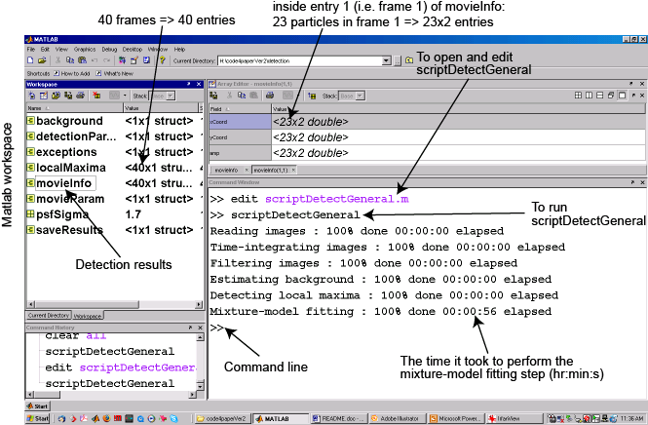

Figure 1: Illustration of a successful detection run and output for the example movie in the directory “example”.

Tracking:

After running the detection code, and with the results movieInfo in the Matlab workspace (either directly from scriptDetectGeneral of by loading the file where the detection results were saved into the Matlab workspace), run the tracking code scriptTrackGeneral:

(1) Open the file scriptTrackGeneral.m from the Matlab command line (Fig. 2).
(2) Define the required parameters (explained in scriptTrackGeneral and in Supplementary Note 9):
(i) Cost function and Kalman Filter function names.
(ii) General and cost function-specific tracking parameters.
(iii) Saving results: Indicate the name and location of the file where results should be saved.
(3) Save the changes.
(4) Run scriptTrackGeneral from the Matlab command line (Fig. 2).

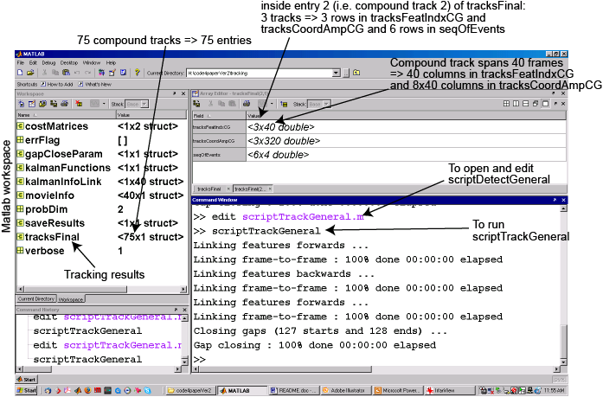

Figure 2: Illustration of a successful tracking run and output for the example movie in the directory “example”.

The important output of scriptTrackGeneral is the output variable tracksFinal (Fig. 2). If the tracker finds N tracks in the movie, tracksFinal will be an N×1 structure array (every element corresponds to one track). These tracks are compound tracks. If, for example, two particles first move separately and then they merge, their tracks will appear together as one compound track entry in tracksFinal.

Every entry in tracksFinal (i.e. every compound track) contains 3 fields:

(1) tracksFeatIndxCG: Connectivity matrix of particles between frames, after gap closing.
Number of rows = Number of tracks merging with each other and splitting from each other (i.e. involved in compound track).
Number of columns = Number of frames the compound track spans.
Zeros indicate frames where a track does not exist, either because those frames are before the track starts or after it ends, or because of temporary particle disappearance.

(2) tracksCoordAmpCG: The positions and amplitudes of the tracked particles, after gap closing.
Number of rows = Number of tracks merging with each other and splitting from each other (i.e. involved in compound track).
Number of columns = 8 × number of frames the compound track spans. For every frame, the matrix stores the particle’s x-coordinate, y-coordinate, z-coordinate (0 if 2D), amplitude, x-coordinate standard deviation, y-coordinate standard deviation, z-coordinate standard deviation (0 if 2D) and amplitude standard deviation.

(3) seqOfEvents: Matrix storing the sequence of events in a compound track (i.e. track start, track end, track splitting and track merging).
Number of rows = number of events in a compound track.
Number of columns = 4.
In every row, the columns mean the following:
1st column indicates frame index where event happens.
2nd column indicates whether the event is the start of end of a track. 1 = start, 2 = end.
3rd column indicates the index of the track that starts or ends (The index is “local”, within the compound track. It corresponds to the track’s row number in tracksfeatIndxCG and tracksCoordAmpCG).
4th column indicates whether a start is a true initiation or a split, and whether an end is a true termination of a merge. In particular, if the 4th column is NaN, then a start is an initiation and an end is a termination. If the 4th column is a number, then the start is a split and the end is a merge, where the track of interest splits from / merges with the track indicated by the number in the 4th column.

The output tracksFinal will be saved in the file specified in Point (2iii) above, and it will appear in the Matlab workspace for use in the visualization code (Fig. 2).

Visualization:

In the directory visualization, there is a function called plotTracks2D which can be used to plot the tracks generated by scriptTrackGeneral. The function can be called from the Matlab command line as follows:

>> plotTracks2D(tracksFinal, timeRange, colorTime, [], indicateSE, newFigure, image)

It takes the following input:
-tracksFinal: This is the output of scriptTrackGeneral. This variable should exist in the Matlab workspace.
-timeRange: Frame range to be plotted, e.g. [20 40] plots the tracks that exist between frames 20 and 40. To plot tracks in the whole movie, enter [].
-colorTime:
-‘1’ to draw tracks with time color-coding (tracks start in green, go through blue, end in red). Warning: This option makes the figure very big and slow if there are many tracks.
-‘2’ to cycle through 7colors and give every track a random color.
-‘r’, ‘b’, ‘g’, etc. to plot all the tracks in the same color, which is the color indicated between quotes (r=red, b=blue, g=green, etc (in Matlab, type ‘help plot’ for line colors)).
-indicateSE: 1 to indicate track starts and ends (with circles and squares, respectively), 0 not to.
-newFigure: 1 to plot tracks in a new figure window, 0 to plot them in an already open figure window (e.g. to overlay two sets of tracks).
-image: In order to overlay the tracks onto an image (e.g. the first image in a movie), supply the image (as a uint16 or double matrix which already exists in the Matlab workspace). In this case, newFigure has to be 1.

If plotTracks2D is called with only the first input argument, i.e. one types the command plotTracks2D(tracksFinal) in the Matlab command line, the code’s default is to plot all the tracks for the whole movie, with all the tracks colored black, showing track starts and ends, in a new figure window without an image underneath.

In the tracks, a dotted line = closed gap, a dashed line = merge, a dash-dotted line = split.

Example:

In the directory example, there is a 40-frame movie (of CD36) that the user can run the software on. The detection and tracking parameters supplied in scriptDetectGeneral and scriptTrackGeneral are suitable for this movie. However, the paths of the images and the results must be adjusted to the specific configuration of the software installation.

